17th Annual Trick or Treat on the Trail
Hickman Area Economic Development Association
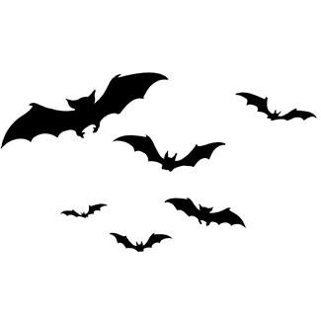
Thursday, October 24, 2024
6:00 pm to 8:00 pm

2024 Registration Form
** Registration deadline October 7, 2024 **

Organization Name: ______________________________________
Contact Name: __________________________________________
Email: _________________________________________________
Address: _______________________________________________
Phone Number: __________________________________________
Alternate Name/Phone Number: _____________________________

Electricity Needed? (limited spots, first come first serve)
Yes _________ No __________

Vendor Option
# 1 _______ (Booth on Trail)
# 2 _______ (Recognition Sponsorship No Booth)

The Vendor Fee is $45.00, which will help to support the
Hickman Trail Lighting Projects.

Please make checks payable to the Hickman Area Economic Development Association (HAEDA) and submit your payment & registration form to the Hickman City Office, 115 Locust Street/PO Box 127, Hickman, NE 68372.

Please email a photo of your booth completely set up to hickman1872@gmail.com prior to the event start time.
HAEDA Contact: Kelly Oelke, City Office 402.792.2212.

